# Glideslope 2.7 MFD User Documentation

© 2012-2018 Andrew “ADSWNJ” Stokes, licensed under GNU GPL  
Based on the original Glideslope © 2006, 2009 Chris “kwan3217” Jeppesen under GNU LGPL  
Incorporating MFDButtonPage © 2012 Szymon “Enjo” Ender under GNU LGPL

## Introduction

Glideslope 2.5 MFD is a spacecraft reentry management tool developed for Orbiter 2016. It is an update to the original Glideslope MFD created by Chris Jeppesen (kwan3217), enhanced with new management screens, HAC geometries, updates to the algorithms and miscellaneous changes throughout.

**If you are looking for support for Orbiter 2010, then please use Glideslope 2.4, as this version and higher is not compatible with the old Orbiter 2010.**

## List of Changes in v2.7

Feature:

1. Added Vertical & Horizontal Acceleration guidance to descend to a base in vacuum (to assist with manual approaches to e.g. Brighton Beach).
2. Now using ModuleMessaging v2 for communications with other MFDs.

## List of Changes in v2.6

Feature:

1. Fixed 0 HAC / NAN bug (thanks to davidweb and turtle91 for flagging this). This version needs BaseSync 3.1 or higher for synchronization now.
2. Added turtle91’s XR1 from ISS reentry glideslope.

## List of Changes in v2.5

Feature:

1. Added support for the new terrain code in Orbiter 2016 **(making this version incompatible with Orbiter 2010)**.
2. Renamed the MFD to Glideslope instead of GS2. (I finally think this version deserves to be the successor to the original Glideslope MFD!).
3. Note – all supporting data now lives in Config/MFD/Glideslope… not Config/MFD/GS2…
4. Further work tuning the hands-off autopilot landing for non-atmospheric planets and moons.

## List of Changes in v2.4

Feature:

1. New fully hands-off autopilot landing for non-atmospheric planets or moons.
2. Rewritten the deorbit system for atmospheric planets to require BaseSyncMFD. You now slave BaseSync to GS2 (for targeting and reentry parameters), and Glideslope 2 picks up the deorbit solution from BaseSync and then the new deorbit autopilot executes the burn.
3. Base selection is now planet/moon sensitive – i.e. Previous Base / Next Base only shows bases for your nearest planet or moon. If there are no bases, then the default landing point is Lat 0, Lon 0, even if on the sun!
4. Minor changes to accommodate runway height, ready for Orbiter 2016
5. Minor changes to information displays to use more consistent terminology (e.g. VSpd, VAcc).
6. Updated and enhanced documentation

## List of Changes in v2.3

Feature:

1. Added Visual Base (VB) config mode to visually select your base and runway. (Thanks *blixel* for the suggestion)
2. Added all the bases and landing pads from 4th Rock’s Orbiter Stock Bases Upgrade.

## List of Changes in v2.1, v2.2

Feature:

1. Added mode titles on each screen (GS2 VSIT, GS2 HSIT, GS2 DATA, GS2 TAPE, GS2 DIAG, GS2 DEOR). (Thanks *blixel* for the suggestion)
2. Added Extended Track Save (XTS) feature to the config screen. Extended track Save saves every 10 secs of track prior to the top of descent. This is useful when you really want to see the whole descent, or for sub-orbital hops.
3. Horizontal Situation mode adjustments for initialization on the ground (e.g. Sub-Orbital hop). Mode no longer thinks you are on final, and now calculates bearing correctly when stationary. (E.g. WIN is 8.2Mm from KSC, not 32Mm).
4. Horizontal Situation mode now suppresses the Delta Azimuth horizontal slider when on HAC and finals (DelAz not useful for those phases of descent).

Minor:

1. Fixed bug in User Save mode, where if the use save glideslope was malformed, then the parse would leave the file open, so the user save would fail.
2. Added Crossrange (XRange) to the Diag screen, if you want to see it at other phases of the descent than just finals.
3. Adjusted X-axis scale of the Vertical Situation mode to cater for the roll-out on the runway. Origin is now 1KM from end of runway, rather than on the front threshold of the runway. (I.e. ALT and TAS no longer end up running off the left side of the VSIT screen!)

## List of Changes in v2.0

Feature:

1. Created Configuration Screen to allow more options to change the configuration in flight.
2. Reference Glideslope now selectable in flight (via config and via new GLIDESLOPE lines in GS2.cfg). (Thanks *Cras* & *boogabooga* for the suggestion.)
3. New color treatment throughout – reference data is now blue, actuals good are green, high yellow, low red.
4. Glideslope screen now has added data in the bottom right (range, delta azimuth and delta reference energy), allowing you to fly just off one screen if you prefer. (With toggle * flash effect warning as you approach the HAC)
5. Return of the reentry screen from the old Glideslope, via a config screen setting. New display data and ability to adjust hypothetical PeA up and down to match BaseSync’s output. Predictors for resulting glideslope angle and vertical speed at entry interface.
6. Horizontal situation screen now has new information at the top relevant to phase of reentry, including delta reference total energy on all phases, range to WP1 and DelAz on reentry, WP2 arc and distance for HAC flight, and crossrange and PAPI distance on final. (Note – adjusting the HAC geometry recalculates the new reference total energy, meaning you get real-time feedback on your HAC adjustments relative to your energy situation.) (Thanks *boogabooga* for the suggestion.)
7. Glideslope 2 now saves and restores config settings in the scenario file, overriding the GS2.cfg defaults. (E.g. remembering where you were flying towards, and what your HAC geometry was).

Minor:

1. Suppressed invalid reference values on Data screen before entry interface.
2. Suppressed glideslope indicator on Horizontal Situation until we are in the HAC.
3. Added an autopilot active indicator on each page (AUT in top right corner). (Thanks *AssemblyLanguage* for the suggestion.)
4. Glideslope trace reset option (via config) … to clean up the glideslope history. (Thanks *Cras* for the suggestion.)
5. AoA setting now locked to degrees (no more millidegrees). (Thanks *indy91* for point this out.)
6. Optional display of internal diagnostics (via config setting).
7. Fixed rare / random CTD on Glideslope 2 launch. (Thanks *Cras* for flagging this one.)
8. Reduced the size of the source code zip. (Thanks *Enjo* for the tip!)

## 

## Pre-requisites

You need to install the MSVC++ 2010 SP1 redistributable from Microsoft. (Go here:  
<http://www.microsoft.com/en-us/download/details.aspx?id=26999> ). Telltale sign of not doing this … it will complain about a missing MSVCR100.dll file. (Thanks *Wrangler* and *Orb* for flagging this dependency.)

## MFD Purpose

Glideslope 2 MFD assists the Orbiter pilot to make a safe reentry, descent, “heading alignment cylinder” (HAC) turn and landing at a base and runway of their choice on Earth, or on a planet with an atmosphere. It also provides full landing support for non-atmospheric planets and moons. Glideslope 2 provides vertical & horizontal situation displays and digital & tape-style flight descent data to provide the pilot with optimal situational awareness to make a safe landing, either with propulsive thrust, or (for atmospheric landings) optionally gliding to a controlled landing without thrust.

**NOTE: the pictures that follow show GS2 v2.4, but the actual screens will now show Glideslope v2.5.**

## Left Side MFD Button Definitions and Usage

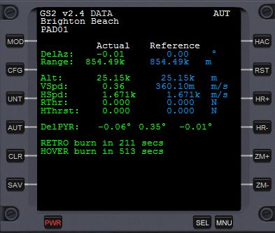

* **MOD = Mode Select**
  + Cycles through six mode screens: vertical situation, horizontal situation, digital descent data, tape descent data, deorbit control, and diagnostics. The last two modes are off by default, and can be enabled on the configuration settings screen (press CFG to access this screen).
* **CFG = Configuration Settings**
  + Switches to the Config Settings screen, for targeting base and runway, to enable the deorbit and diagnostics screen, and to select different reference glideslopes.
* **UNT = Units Select**
  + Toggles Metric or US (Imperial) measurements.
* **AUT = Autopilot**
  + Toggles on/off a full autopilot for non-atmospheric landings, or a basic autopilot for atmospheric landings. If your spaceship has attitude control and you are landing into an atmosphere, use that feature instead of this autopilot.
* **CLR = Clear Track History**
  + Resets the yellow and green track history on the screen (for example, to declutter the screen after selecting a different runway).
* **SAV = Save User Glideslope**
  + Creates a user saved glideslope in configuration file format, so you can set up your own reference glideslopes per spacecraft or planet, etc. Use this if you have just done a model landing (or close to what you want), and you want to use this as a benchmark glideslope for a future landing.

(The right side buttons will be covered later with the Horizontal Situation description)

## Config Menu Mode

This menu allows you to adjust general configuration settings in flight.

* **OK = Return**
  + Hit Ok to return to the previous mode screen.
* **PB / NB = Previous / Next Base** 
  + Selects the previous/next base in the config file (or does nothing if just one base defined)
* **PR / NR = Previous /Next Runway**
  + Selects the previous/next runway at this base in the config file (or does nothing if just one runway defined at this base)
* **VB = Visual Base mode**
  + Visually displays the runway and landing pads at your selected base
  + Allows you to select PB / NB and PR / NR whilst looking at the target base and active runway or pad.
* **DEO = Toggles the Deorbit screen on or off**
  + This option toggles display of the Deorbit screen into the mode cycle (MOD button) on the main display
* **PG / NG = Previous /Next Glideslope**
  + Selects the previous/next pre-defined Glideslope in the config file (Note – if you do not specify a glideslope in the config file, a default one will be selected).
* **DIA = Toggles the Diagnostic screen on or off**
  + *TECHNICAL ONLY*. This option toggles display of the Diagnostic screen into the mode cycle (MOD button) on the main display. Nothing too interesting down here – just some added data like Mach number and Heat Flux, and whatever I was debugging last!
* **XTS = Toggles the eXtended Track Save on or off**
  + *TECHNICAL ONLY*. If you are saving a glideslope to generate a new reference glideslope for later, or if you want to see more data than the default track save option, then toggle this setting on. All you will see different is a bigger glideslope save file in your Config/MFD/Glideslope/Diags folder.
* **QAR = Toggles the Quick Access Recorder on or off**
  + *TECHNICAL ONLY*. This option toggles a further diagnostic file for analysis offline. See your Config/MFD/Glideslope/Diags folder for details.

## Visual Base Mode

## 

This configuration mode shows additional information about your target base, runways and alignment. In addition to the base and runway, you will notice that the latitude / longitude, runway length and runway width are also displayed. The runways are depicted in gray for non-selected, and green for selected, with an arrow marker showing the approach direction. The pads are displayed as circles, gray for non-selected, and green for selected.

* **OK = Return**
  + Hit Ok to return to the previous mode screen.
* **PB / NB = Previous / Next Base** 
  + Selects the previous/next base in the config file (or does nothing if just one base defined)
* **PR / NR = Previous /Next Runway**
  + Selects the previous/next runway at this base in the config file (or does nothing if just one runway defined at this base)
* **RST = Reset View**
  + Resets the view to center on the selected runway or pad center, at default zoom
* **ZM-/ZM+ = Zoom Out/In**
  + Zooms the view out or in
* **UP/DN**
  + Moves the view up or down
* **< / >** 
  + Moves the view left or right

## Vertical Situation Mode

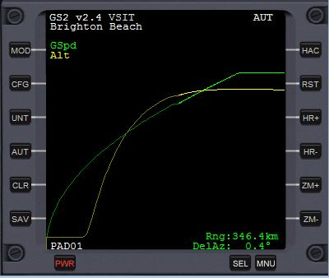

This mode shows the vertical airspeed and altitude profile for your glideslope. It’s the primary mode for the descent phase from the deorbit point to the approach to the HAC. The Information displayed is as follows:

* **Green traces = Current True Air Speed (bright green) versus Reference Air Speed (dull green), and**
* **Yellow traces = Current Altitude (bright yellow) versus Reference Altitude (dull yellow)**
  + You can get the actual values from the Digital Descent Data screen. These trend lines give you situational awareness of your altitude and speed, allowing you to adjust your attitude or thrust to align with the reference glideslope
  + The reference glideslope is selected by you on the CFG screen, or is auto-generated for non-atmospheric landings, according to your height, speed and the gravity of the reference planet or moon
  + The horizontal axis of this diagram represents your range to landing, and it will auto-scale several times during the descent. If you are close to base and you change the runway or HAC geometry, expect to see discontinuities on these traces. You can clear the trace history using the **CLR (Clear Traces**) button.
* **HAC = Range to HAC entry**
  + Indicates your range to the HAC. When this is within 200km of the HAC, you will notice an alternating flashing asterisk next to the HAC to draw your attention to the impending end of the main descent phase. (Not applicable on non-atmospheric landings.)
* **DelRefTE = Delta Reference Total Energy**
  + This is a percentage indicator of your energy situation relative to the reference glideslope. Total Energy is the sum of Potential Energy (from altitude) and Kinetic Energy (from airspeed). Use this to monitor your overall energy state and trend as you come down the main descent.
* **DelAz = Delta Azimuth**
  + This is the track offset to the HAC waypoint. Trend this to zero by the time you get to the HAC, either by doing “S-turns” (i.e. large roll maneuvers maintaining your angle of attack), or use thrust.

## Digital Descent Data Mode

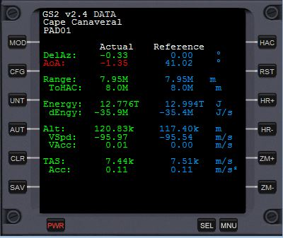 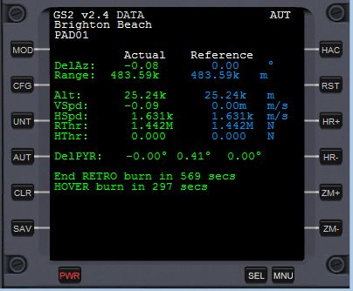

This mode shows the critical descent parameters you need to focus on. These two screenshots show the data for an Earth landing (left) and a Moon landing (right). Your actual data will be in green (ideal), red (low) or yellow (high). The reference data is always in blue.

Atmospheric Data Meanings:

* **DelAz = Delta Azimuth**
  + Indicates your ground track bearing offset to the next waypoint. There are three waypoints on the descent: the entry to the HAC (WP1), the exit from the HAC (WP2) and the touchdown point (TDP). During the main descent, you are tracking to WP1. In the HAC, WP2. On final, TDP. For a non-atmospheric landing, the WP1 is directly overhead the target base pad.
* **AoA = Angle of Attack (Alpha angle)**
  + This is your wing angle relative to airflow, and critical for lift / stall, and vertical descent control.
  + Try to pay close attention to this as you come down the main descent through the highest heat phase, adjusting by half-degrees to keep your vertical speed (VSpd) where you need it.
* **Range, ToHAC = Range to TDP, and Range to HAC entry**
  + Indicates your range to touchdown point, and additionally the range to HAC on the main descent. As range to HAC comes down to say 50km to go, ensure you have the Horizontal Situation up for the HAC.
* **Energy, dEngy = Total Spaceship Energy, and Delta Energy (rate of change of energy over time)**
  + Sum of gravitational potential energy (PE) and kinetic energy (KE). Use this to keep your overall energy situation under control, and to track the delta energy to trend it towards reference.
* **Alt, VSpd, VAcc = Altitude, Vertical Speed, and Vertical Acceleration**
  + Keep an eye on your altitude and rate of change, relative to reference. If everything is in the green, then watch your VSpd and keep that close to the reference by adjusting AoA up and down 0.5 degrees at a time. Once you have a good VSpd, then keep your VAcc close to zero to maintain your VSpd.
* **TAS, Acc = True Air Speed, and Horizontal acceleration**
  + You need to get your TAS down to around 800 m/s before HAC entry. Slow down faster by presenting more resistance to the airflow – i.e. raising your AoA. But balance this with the increasing vertical speed. Trend both air speed and altitude to keep your total energy in the green (high and slow / low and fast are both easily correctable).

Non-Atmospheric Data Meanings:

* **DelAz, Range = Delta Azimuth and Range to Base**
  + As above on the atmospheric screen
* **Alt, VSpd = Altitude, Vertical Speed**
  + As above on the atmospheric screen
* **HSpd = Horizontal Speed**
  + As TAS on the atmospheric screen, but of course we have no air here!
* **RThr, MThr = Retro Engine Thrust or Main Engine Thrust**
  + Amount of retro thrust or main engine thrust needed to decelerate smoothly to end up at the base
  + If the Retro engines are enabled and the vessel can slow down in time on the retro engines, then they are preferred. If not, you will be commanded to go to retrograde orientation and use your main engines instead
* **HThr = Hover Engine Thrust**
  + Amount of hover engine thrust needed to counteract gravity and end up smoothly at the right altitude over the base
* **Del PYR = Delta Pitch, Yaw, Roll**
  + Alignment commands to position the vessel correctly for the burns
  + As you approach 5 minutes before the main retro-burn, you may be commanded to roll either +90 or -90 for a base alignment burn, using the hover engine. During the retro phase, you will be commanded to yaw left or right to maintain base alignment. You are strongly encouraged to just hit AUT and watch the autopilot do it for you
* **Commands**
  + Various control commands will be displayed at the bottom of this screen. For example, to ask you to align for a burn, or a countdown to a start or stop of a burn
  + When the command is imminent, the text will change color to yellow

## Tapes Descent Mode

This is an alternative display of the reentry data, mimicking an analog cockpit if you prefer your data in that format. You have similar data to the Digital Descent Data Mode, but this is a more visual way to fly the descent rather than focus on the numbers so much.

* **Range** 
  + Simple range to base measurement
* **Vertical pointer line**
  + Angle of Attack data, with the reference in blue on the left, and the current on the right (color-coded white, red or green for high, low or nominal).
* **Horizontal pointer line**
  + Delta Azimuth data, showing deviation to the desired track
* **TAS tape**
  + True Air Speed tape, showing current speed in the middle and the reference speed on the tape
* **dTAS tape**
  + Delta True Air Speed, showing rate of change of airspeed
* **ALT tape**
  + Altitude tape, showing current altitude
* **VSPD tape**
  + Vertical Speed (or delta Altitude), showing rate of change of altitude
* **VACC tape**
  + Vertical Acceleration tape, showing rate of change of VSPD

This mode is retained for historical reasons, as it was the primary data interface for the original Glideslope, but the Digital Descent Data is now the preferred mode for accessing this information.

## Right Side MFD Button Definitions and Usage

Before describing the Horizontal Situation modes, let’s introduce the right side MFD buttons:

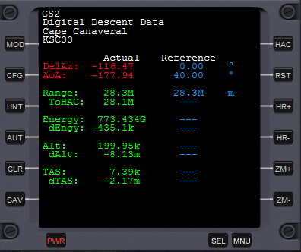

* **HAC = Heading Alignment Circle Geometry Selection**
  + Toggles through four HAC modes: left-entry closed HAC, left-entry open HAC, right-entry closed HAC and right entry open HAC. These modes govern the positioning of the HAC, where you enter and exit, and whether or not you need to do a full lap before exiting the HAC or not.
* **RST = Heading Alignment Circle Reset**
  + Resets the HAC settings back to default geometry, HAC radius and Auto-Zoom. Useful to allow you to play with various settings and then quickly reset back to normal.
* **HR+ = Heading Alignment Circle Radius Increase**
  + Increases the size of the HAC and the distance of the final approach. Useful when you are high energy (particularly high speed so you cannot pull a tight turn). This mode has a reset at 3x the HAC radius, so you do not increase the HAC turn without limit!
* **HR- = Heading Alignment Circle Radius Decrea3se**
  + Decreases the size of the HAC and shortens the final approach. Useful for low energy situations, where you cannot afford to do the full circle, or you want to tighten the approach as much as possible to a straight-in landing. This mode shrinks the HAC radius as tight as 500m (fly it “open”) and the final to 8km to allow a minimal final line-up before landing.
* **ZM+, ZM- = Manual Zoom In and Out**
  + By default, this mode will auto-zoom appropriate to your range to touchdown. These buttons override the auto-zoom and allow you to lock it to your preferred zoom. This is useful in certain recovery situations where you want to see a broader view of the HAC, or where you want to zoom in to see a closer view of your flight path relative to the HAC.

## Horizontal Situation Mode

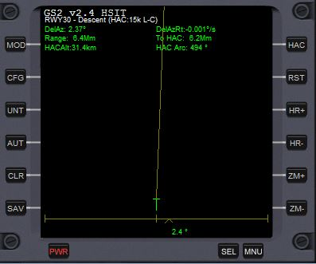

This mode presents your horizontal situation relative to the HAC turn and final approach to landing. The display elements change depending on what phase you are in on the reentry. The first screen is the Descent mode, indicated by “Descent” after the selected runway. The screen elements here are as follows:

* **Runway, Phase, HAC size, HAC entry, HAC open/closed**
  + The selected runway name is displayed
  + Phase is “Descent” for the Main Descent to the HAC until you reach the HAC turn.
  + The HAC information shows the current HAC radius (15km), entry direction into the HAC (L for left-turn, R for right-turn) and open or closed (O for open: meaning you will do a partial lap, C for closed: meaning you will do a full 360 degree turn and then a bit more).
* **Range, ToHAC**
  + Range to runway and Range to HAC turn, as on the Digital Descent Display, color coded to indicate nominal difference to the reference (green), above reference (yellow) or below reference (red).
* **DelAz**
  + Delta Azimuth, as on the Digital Descent Display, and color-coded appropriately.
* **Main yellow track**
  + Reference horizontal flight path, showing the deflection to the HAC waypoint 1 (WP1).
* **Green track and Green Cross indicators**
  + Current track and predictions for the next minute, based on bank angle and turn rate
* **Horizontal pointer and value**
  + Delta Azimuth presented visually.

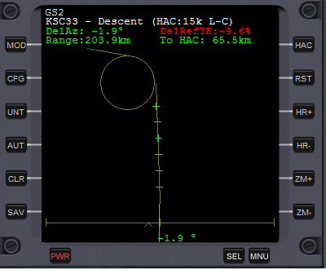  
  
This view of the Horizontal Situation mode is now approaching the HAC, with 65km to the turn. As you can see, the yellow track now shows the full HAC, the final approach and the runway is now visible in green at the end of the glideslope track.

Also notice that the energy situation on this approach is now low (-9.6% off-nominal), so an adjustment to the HAC turn should be considered to reduce the deficit.  
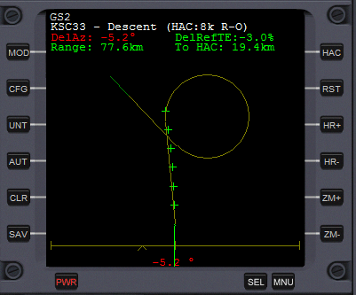  
  
A few more kilometers down the glideslope, and as you can see, I have adjusted the HAC to now be an 8km turn, right entry turn into the HAC, open ended (i.e. exiting without doing a whole lap). This geometry brings the Delta Ref TE closer to nominal energy again, and we are doing a nice circle-to-land approach, crossing over the extended centerline with the runway on our left side.

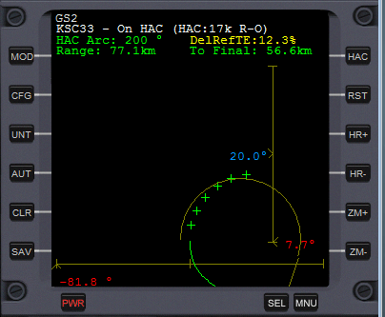  
   
This screen shot shows the second phase of the reentry, now in the HAC turn. The screen elements are:

* **Runway, Phase, HAC size, HAC entry, HAC open/closed**
  + Phase is now “On HAC” indicating we are on the HAC turn
* **To Final**
  + The ‘To HAC’ range now turns into ‘To Final’, meaning the top of the final descent to landing.
* **HAC Arc**
  + This indicates the remaining arc degrees to final.
* **Main yellow track**
  + This track will now be auto-zooming to present a larger display. You can override this with the manual zoom (ZM+/ZM-) buttons.
* **Glideslope indicator**
  + The reference glideslope is 20°. As you come around the HAC, your actual glideslope will adjust according to your attitude. Typically, you enter the HAC with the Glideslope low (say 5-10°), and watch it come up towards nominal as you do the HAC turn. As it gets close to target, adjust your descent to hold that slope until the PAPI lights.

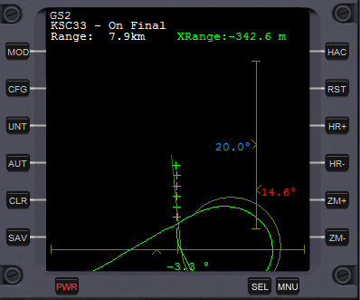 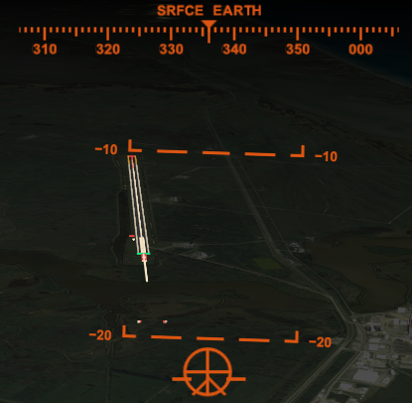

This screen shot shows the third and final phase of the reentry, now on final approach. (The cockpit view is also shown for comparison to the Glideslope 2 display).

The new screen elements here are as follows:

* **Runway, Phase**
  + Phase is now “On Final” indicating we are on final approach.
* **Range**
  + The Range is the range to the touchdown point
* **XRange**
  + The XRange range is the cross-range offset to the PAPI lights (notice the PAPI’s on the cockpit view – offset 2km from the runway threshold). Use this as an aide for precision line-up, though by now you should be focused on the actual runway!

Fly towards the PAPI lights, using your airbrake as needed to get your speed ready for landing (e.g. 180-220 m/s for an XR spaceship). Very close to the PAPI’s, deploy your gear, and smoothly pull up your nose into a 1%-3% slope to pick up the inner glideslope VASI or Ball/Bar lights. An ideal inner glideslope puts the white ball on top of the red bar. (Notice on the cockpit view above, the whist ball is below the red bar, as we are still on the steeper outer glideslope.

Your touchdown point should be adjacent to those lights.

## HAC Geometries on the Horizontal Situation Mode

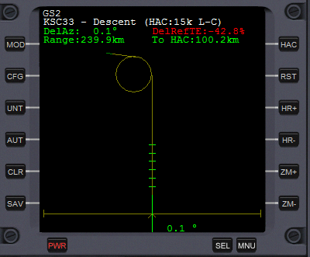 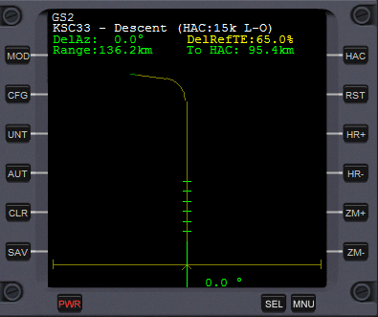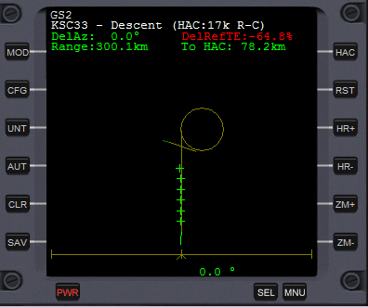 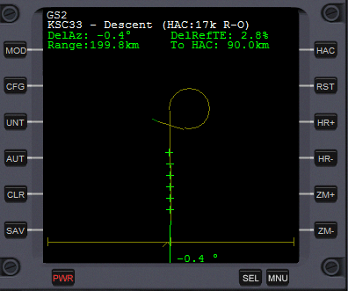

These four sample screens show the four HAC geometries, selected with the HAC button.

* **Left-Closed (L-C)**
  + You will fly the rest of the approach to the HAC entry point (WP1), left turn into the HAC, do a full lap and then exit at the top of final (WP2) for landing. Range to base is the remainder of your approach to WP1, a full lap of the HAC, the arc range from WP1 to WP2, and the final distance to touchdown.
* **Left-Open (L-O)**
  + Opening the HAC removes the requirement to fly the full circle. Use this mode when you are low energy. Range is now just range to WP1, arc to WP2, final to touchdown.
* **Right-Closed (R-C)**
  + Right entry moves the HAC position to the far side of the runway. Useful for high energy, where you want more space to slow down pre-HAC entry.
* **Right-Open (R-O)**
  + Same as L-O, removing the requirement to fly the full lap.
* Press **RST to reset** the geometry and size to default.

## Deorbit Mode

The goal of the deorbit mode is to complete the retro-burn at the correct time and on the correct orbit, to deorbit you into the start of the chosen reference glideslope, at the right altitude, reentry angle (i.e. how steep is your descent), and anticipation angle (i.e. how many degrees from the start of reentry to the landing).

Glideslope 2.4 and higher has been designed to integrate tightly with BaseSync MFD version 3.0 or higher. Please download and install this add-on if you do not have it.

By default, the Deorbit Mode is disabled. To enable it, go to the CFG screen, press DEO, and press OK. As you cycle through the modes with the MOD button, you will now find the Deorbit Mode. If you have not yet selected BaseSync MFD, then you will see the following screen:  
  
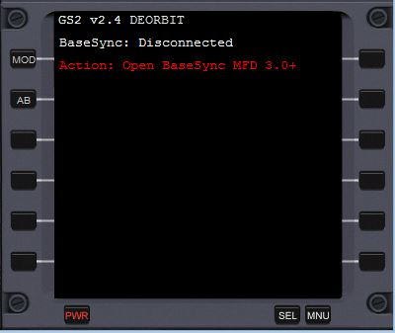

When you open BaseSync MFD, Glideslope 2 interrogates the selected target in BaseSync. If there is a mismatch, you will see this screen:

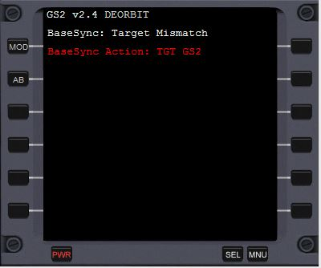

Complete the required action in BaseSync, by pressing TGT and then entering GS2 (you may also select GS on BaseSync version 3.1). On BaseSync 3.0, you will now see that the target says “Linked to GS2” (“Linked to GS” on BaseSync 3.1), and so you have now interconnected the two MFD’s:

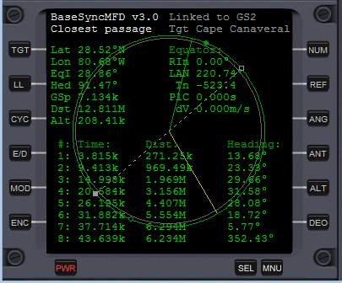

On Glideslope 2, you will see the BaseSync status as connected, and then further instructions. In this case, it is waiting for BaseSync to confirm that we are on the best reentry orbit. It also suggests that you press AB to allow Glideslope to do the alignment and burns for the reentry burn. (You may do it manually, of course.)

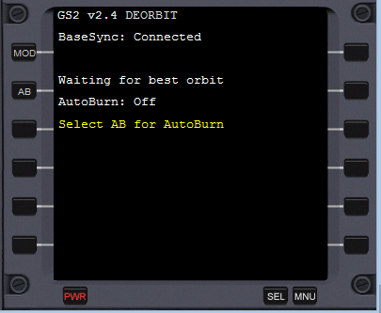

If you select AB and wait until the best reentry orbit is #1 in BaseSync, you will then see this screen asking you to select DEO mode in BaseSync:

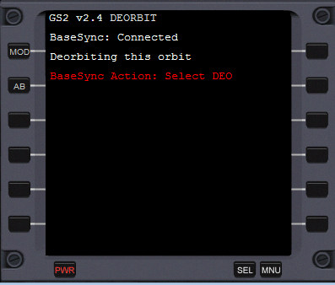

Selecting DEO in BaseSync brings you to the retro burn countdown screen:

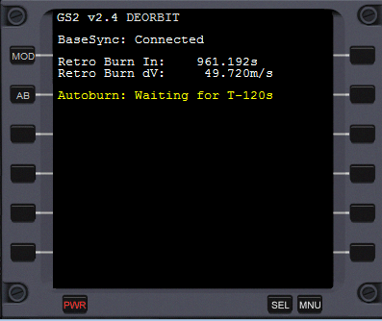  
  
If you have the AutoBurn off, you get a warning as follows.

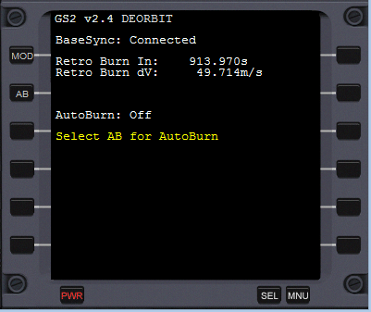

The process for executing the burn is (1) align to retrograde, (2) execute a main engine full burn at the exact point when the timer hits zero, (3) burn until the dV is close to zero, (4) trim the remaining dV to get it as close to zero as possible, (5) align to prograde. The autoburn does all this for you, including controlling maximum time acceleration to maintain accuracy (i.e. no more than 10x acceleration for the alignment, no more than 1x for the burn, and no more than 0.1x for the trim).

If you use the autoburn, it will leave you in prograde mode, with the following message:

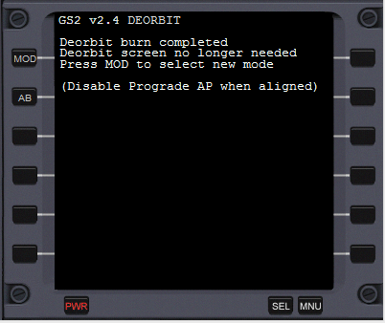

## At this point, you can select MOD to return to the main reentry screens, and the deorbit mode will be switched off. Deselect Prograde AP at your discretion – e.g. as you approach the entry interface, when you want to roll horizontal and then pitch up into the correct reentry attitude. Non-Atmospheric Landings

Introduced in the previous Glideslope 2.4, Glideslope 2 MFD now has the capability to do a guided landing onto a vacuum body (e.g. the Moon). In order to do this, Glideslope calculates the required retro and hover burns to bring the spacecraft to a hover point 1km from the base, then does a precision guided landing onto the pad of your choice. Let’s use the example of a landing into Brighton Beach Pad 6, on the Moon, from a 30km altitude circularized orbit. (Note: if your orbit is not circular – e.g. Eccentricity greater than 0.010 – then the range calculation will be incorrect, and the autopilot may not be able to adjust to land you safely.)

Start Glideslope 2. 5 and BaseSync 3.0 (or higher). In BaseSync, press TGT, and select GS2 to connect the MFD’s. In Glideslope, select CFG and select Brighton Beach (using PB and NB). (You will notice that this is now much easier than before, as the base selection only shows applicable landing places on the body you are orbiting.). Press PR/NR to cycle through the landing options at Brighton Beach. As you do this, notice that BaseSync is adjusting its target latitude and longitude to align to the new landing pad selection (i.e. we are accurate to the pad now, rather than to the center of the base). Press OK to exit from the CFG screen, and select the Digital Data mode screen. You will see something similar to this:

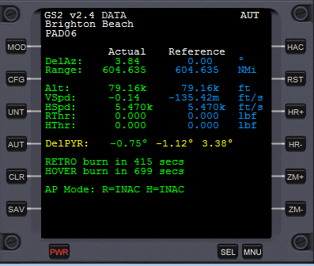

(If you have not enabled the autopilot yet, press AUT, and confirm AUT is showing on the top right of the screen.)

The phases of the auto-landing are as follows:

1. Inactive … either autopilot disarmed, or we are more than 5 minutes from the retro-burn. R=INAC and H=INAC shows that the retro and hover engine modes are inactive.
2. Arm engines … R=ARMD H=ARMD will be displayed.
3. Alignment burn … at approximately 5 minutes prior to the retro-burn, if the cross-range error (‘Dist’ on BaseSync) is significant, then then autopilot will roll 90 degrees (H=POPA) and then burn (H=XBRN) the hover engine to null out that error. Once complete, the spacecraft will roll level again and return to R=ARMD H=ARMD state.
4. Retro burn … if the retro engine is available (i.e. retro doors open) then the autopilot will use these engines (and this gives you a nice view of the landing approach). If not, it will reverse everything and use the main engine instead. The retro burn also biases the burn vector by up to 15 degrees of yaw, to continue to take out any cross-range error. During this phase, R=RTRO H=ARMD will be displayed, showing we are firing the retros and waiting for the right point to control the descent speed.
5. Descend control burn … as the retro engine slows the orbital velocity, the spacecraft begins to descend to the surface. The autopilot uses the hover engine to control the descent velocity. R=RTRO H=DSND will be displayed.
6. Altitude hold … if the height reduces to 2000m, the hover engines switch to altitude hold, whilst the remainder of the retro burn completes. R=RTRO H=AHLD will be displayed.
7. Precision land … when the spacecraft gets near to the base, it switches to precision landing, using the thrusters to achieve an accurate landing. R=PLND H=DSND will be displayed.

Glideslope continuously recomputes the landing trajectory and adjusts throttles and burn vectors to compensate for any errors. If you are flying manually, you need to watch very carefully for the throttle changes and the trigger points, to try to copy what the autopilot would be doing. Note that it is strongly recommended to use the autopilot for landing.   
  
New as of version v2.7 is the VAcc and HAcc lines on this display. These continuously compute the required decelerations needed to arrive at the base with zero residual velocity. Consider decelerating slightly more than these settings, and then throttling back as you approach the target. (If you decelerate at exactly the amount, then this is the equivalent of a ‘hoverslam’ approach.)

## Save User Glide Slope Data

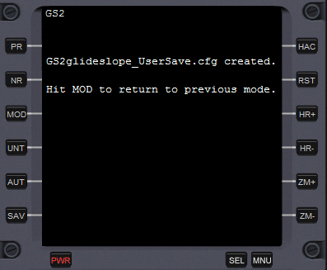

If you want to review your last descent and landing after exiting the Orbiter simulator, hit SAV. This writes a file Glideslope_UserSave.cfg into the Config\MFD\Glideslope directory. If that approach was awesome enough that you would like to make it your new glideslope for that vehicle or planet, or even if you want to use it to see how close you can recreate your previous approach, you can use this config file directly as input to Glideslope for your next flight. You do this by setting up the Glideslope.cfg PREFS to point to UserSave, or rename your glideslope to your choice of name to avoid it being overwritten. For details on the configuration files, please see the next page.

## Glideslope 2.x Configuration Settings

You have extensive ability to configure Glideslope 2.x through configuration files. Find them in Config\MFD\Glideslope in your Orbiter directory tree. The base distribution has a master config file, Glideslope.cfg, and a number of glideslope config files of format Glideslope_{name}.cfg.

### The Glideslope.cfg file

Glideslope.cfg defines the bases, runways and preferences for Glideslope 2. The default Glideslope.cfg has extensive comments to help you format it correctly. This is a summary of those comments:

Blank rows and rows starting with semicolons are ignored. Every other line needs to start with either BASE, RUNWAY, GLIDESLOPE or PREFS.

The BASE definition specifies a planet, then a name for the surface base and its longitude and latitude. Example:

BASE "Earth" "Cape Canaveral" -80.675 +28.5208

(You get this information from the respective surface base definition file for the planet).

The RUNWAY definition specifies a runway name, runway near and far end offsets, runway PAPI offsets and VASI offsets. Example:

RUNWAY "Cape Canaveral" "KSC33" -8220 -600 -12670 -3155 -2000 671

RUNWAY "Cape Canaveral" "KSC15" -12670 -3155 -8220 -600 -2000 671

The runway must reference a previously defined surface base (i.e. BASE “EARTH” “Cape Canaveral”… must exist before RUNWAY “Cape Canaveral” … lines will be recognized). The runway name is something you have to create yourself, as for some reason this is not in the main surface base definition files (this is a main reason Glideslope 2 reads this from a separate file). The runway offsets (e.g. -8220 -600 -12670 -3155 for KSC33) come from the End1 and End2 definitions in the surface base file (parameters 1 and 3 from End1, and the same for End2). The PAPI and VASI information comes from the RUNWAYLIGHTS block for your runway. If not present, -2000 and +500 work just fine. (Glideslope uses the PAPI point to mark the end of the 20-degree final glideslope, and the VASI point to mark the touchdown point. A PAPI of -2000 targets the main glideslope 2km from the foot of the runway, and marks the point you do the pre-flare for a soft landing. A VASI of +671 puts the touchdown point 671m down the runway.)

The GLIDESLOPE definition specifies a glideslope name and display name. Example:

GLIDESLOPE XR "XR Series"

GLIDESLOPE Shuttle "Space Shuttle"

GLIDESLOPE UserSave "User Saved"

The glideslope name corresponds to a valid glideslope file name matching the format: Glideslope_{name}.cfg. If the file does not exist, or the data is not parsable as a valid glideslope, then the entry is ignored.

The glideslope display name is the friendly name for the Config Menu. Note – by putting UserSave in the GLIDESLOPE parameters, you can directly re-fly the last saved Glideslope (e.g. if you are practicing the same approach repeatedly).

The PREFS definition specifies your choice of start mode for the left, right and external MFD’s, the Units, the default runway, and your glideslope file. Example:

PREFS DATA VSIT HSIT METRIC "KSC33" XR

The first three terms are the default starting modes for the screens (VSIT = vertical situation, TAPE = tape display, DATA = digital descent and HSIT = horizontal situation, DIAG = Internal Diags, DEOR = Deorbit). The next entry is US or METRIC, to select the starting unit-preference. The next is the default runway (must refer to a RUNWAY line above). The final term is the glideslope name, which must correspond to a pre-defined GLIDESLOPE entry.

Glideslope is hardcoded to 64 bases, 128 runways and 64 glideslopes. (It’s easy to increase if you need it, so long as you send me your proposed Glideslope.cfg file with all the new base definitions so I can roll into the main distro!!)

### The Glideslope_{name}.cfg file

The last parameter of the PREFS line in Glideslope.cfg specifies the reference glide slope configuration file. The main distribution comes with three sample glideslopes for XR, Shuttle and DG spacecraft. If you hit SAV after a landing, you will generate a Glideslope_UserSave.cfg as well.

You are free to create any number of glideslopes matching this naming format, for different spaceships and situations (e.g. landing a DG-IV to Olympus Base on Mars). Just fly the approach, save your glideslope, rename it to your preferred name (e.g. Glideslope_DGIV_Mars.cfg) and reference it from the master Glideslope.cfg to activate it.

The glide slope format ignores blank lines and semicolon comments. The active components are UNITS, BEGIN GLIDESLOPE and END GLIDESLOPE. Between BEGIN GLIDESLOPE and END GLIDESLOPE, you put up to 256 rows of glide slope waypoints.

UNITS definition is similar to the Glideslope.cfg – US or METRIC. It sets the units for the glideslope. Note – you can set a glideslope with METRIC units and then display in US units, or vice-versa as you wish. I.e. the UNITS setting here is only to define the glideslope waypoints.

The glide slope data is rows of five numbers, with an optional trailing comment: range, altitude, true air speed, vertical speed and AoA.

The SAV function creates data in this same format. You may edit the values as you prefer, to smooth out any imperfections in your flight, or to drive the reference to achieve something different (e.g. fly at zero vertical airspeed for 40KM before the HAC entry, or hit the HAC much higher). Basically, you can set it up as you wish!

### The Glideslope-Rates.cfg file

This file holds configuration data for vacuum pitch / yaw / roll for various vessels. The data is calculated as a one-off if not found for your vessel. This data is used for the vacuum landing autopilot logic.

### The Parse Logs in Config\MFD\Glideslope\Logs

This directory indicates how Glideslope parsed the master config file and how it parsed any referenced glideslopes. Ordinarily you will never need to look at this, but it is included for diagnosis if we ever run into parse issues on custom glideslopes, etc.

### The Diagnostic Logs in Config\MFD\Glideslope\Diags

This directory is for internal diagnostics only. The DeoBurn.csv shows how the atmospheric deorbit burn was executed. VacuumCalc.csv is the forward prediction trace for a future vacuum landing. GSvacLandAP.csv has the main vacuum landing autopilot. GSvacLandAlign.csv shows how the precision land was executed.

If you have questions on this, please post them to the Orbiter Forum.

## Author’s Comments and Recognitions

My name is Andrew Stokes (ADSWNJ) and I have been flying the Orbiter since 2011. It is a truly fascinating simulator, which invites you to engage at any level from casual to deeply technical. From my early days of getting a Delta Glider into orbit, to doing the first landings on the Moon and Mars, and to doing rendezvous with space stations and orbiting bases, to executing deep space voyages out to Saturn and Neptune, it’s been an addictive pastime. To Dr Martin Schweiger – thank you for an amazing platform that has created this community.

At each level of understanding, you can generally figure it out in a few hours to a point of basic competence, but mastering each activity takes a lot longer. In all my journeys, mastering the unpowered descent and landing was my hardest challenge. In January 2012, TMac3000 posted “My first unpowered landing”, and the comments from Jarvitä, Tommy and PhantomCruiser inspired me to want to improve my performance. I had used the excellent Glideslope 1 from Chris (kwan3217) Jeppesen for a long time, and I was fascinated to look at the source code he released. I’ve coded off and on for much of my life, on everything from tiny systems with 4K of RAM to mainframes. I wanted to get into addon development for Orbiter, and this seemed as good as anywhere to start!

So, with great respect and recognition to Chris’s original code, which took me many weeks to figure out how it worked, I created Glideslope 2 for this community, complete with source code to let the code live for future authors to develop further. To the casual end-users, I hope that this gives you a greater feeling of control for your reentries and landings back on Earth. To the developers or potential developers, hopefully this source code will inspire you to understand how it works and go build something even more awesome from the bones of this code. If you ever feel the urge to take on this application and develop it further, then know that you have my full support, so long as you continue to release the source alongside the DLL.

I would like to thank my fellow addon developers, spacecraft designers, graphics clients, MFD’s and scenarios, and the scores of rocket scientists and physicists (in the truest sense of the word) who contribute to the forums and make them great places to learn.

Cheers, Andrew  
Sep 2016